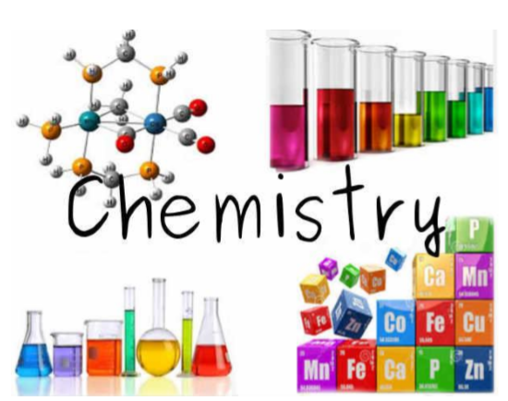
Preparation Work for
A Level Chemistry
Congratulations for joining the best subject out there!
This course will challenge you, but it is worth it, and together we can do it!
We have put together this preparation pack: whilst not exhaustive, it should help you to ease the transition into A level Chemistry.
As ever, keep in touch if you need help.
This work should be handed in to your teacher when you start your A level course, and will count towards your suitability for studying Chemistry at A level.

Due: Friday 16th September

The Chemistry team - Mr White (DWh), Miss Drury (LDt), Miss Jina (SJi) and Miss Sumpter (HSu).
Topic 1 – Structure of the atom and periodic table
- Complete the table below using the periodic table to help:
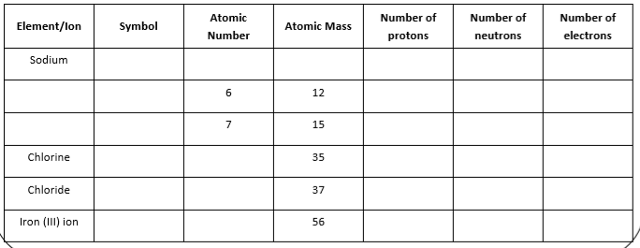
2. a) Define the term ​atomic number​ of an element.
_____________________________________________________________________
b) Define the term ​relative atomic mass ​ of an element.
__________________________________________________________________________________________________________________________________________
3. In terms of the number of their fundamental particles, what do two isotopes of an element have in common and how do they differ?
__________________________________________________________________________________________________________________________________________

4. Explain how the reactivity of group 1 changes as you go down the group.
____________________________________________________________________________________________________________________________________________________________________________________________________________________________________________________________________________________

Topic 2 – Equations
- Balance these equations:
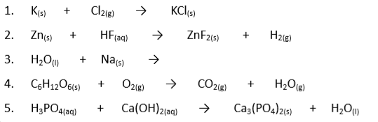
- Determine the chemical formulae of the following ionic substances (some ions have been given to you, others you should know from GCSE)

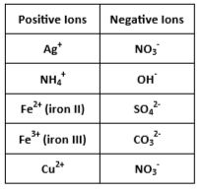
- Silver nitrate = ______________
- Ammonium hydroxide = ______________
- Calcium chloride = ______________
- Iron (II) sulfide = ______________
- Sodium nitrate =______________
- Copper sulfate =______________
- Potassium carbonate =______________
- Iron (III) nitrate = ______________
- Aluminium oxide = ______________

- For the following chemical reactions, write a word and balanced symbol equation:
- Neutralisation of sulfuric acid by potassium hydroxide
__________________________________________________________________
- Thermal decomposition of copper carbonate
__________________________________________________________________
- Combustion of ethane
__________________________________________________________________
Topic 3 – Calculations
Conversions
1. Convert the following masses into grams:
a) 0.25 kg _______________________________________________
b) 15 kg _______________________________________________
c) 100 tonnes ______________________________________________

2. Convert the following volumes into dm³:
a) 100 cm³ _______________________________________________
b) 25 cm³ _______________________________________________
c) 50 m³ _______________________________________________

Significant figures and standard form
- Write the following numbers to the quoted number of significant figures (sig figs).
- 345789 to 4 sig figs = _______________________________________________
- 297300 to 3 sig figs = _______________________________________________
- 0.07896 to 3 sig figs = _______________________________________________

- Write the following numbers in non standard form.
- 1.5 x 10⁻³ = ________________________________________________
- 0.046 x 10⁻² = ______________________________________________
- 3.575 x 10⁵ = _______________________________________________

- Write the following numbers in standard form.
- 0.000167 = _______________________________________________
- 0.0524 = _________________________________________________
- 34500 = ____________________________________________

Moles
1 mole = 6.02 x 10²³ particles (known as Avogadro’s number)
- If you have 2.5 x 10²¹ atoms of magnesium, how many moles do you have?
_____________________________________________________________________
_____________________________________________________________________

Calculations
- From a measurement of MASS:
number of moles = mass/molar mass n = m/mr
Mass MUST be measured in grams! Molar mass has units of g mol⁻¹
- Calculate the number of moles present in:
a)2.3 g of Na ___________________________________________________________________________
b) 2.5 g of O₂ ___________________________________________________________________________
- Calculate the mass of:
a) 0.05 moles of Cl₂ ______________________________________________________________________
b) 0.125 moles of KBr ____________________________________________________________________

- From a measurement of AQUEOUS VOLUME:
number of moles = molar concentration x aqueous volume (n = C x V )
Aqueous volume MUST be measured in dm³! concentration has units of moldm⁻³
Molar concentration (moldm⁻³) x mr = mass concentration (gdm⁻³)
- Calculate the number of moles of substance present in each of the following solutions:
- 25cm³ of 0.1 mol dm⁻³ HCl ______________________________________________________
- 40cm ³ of 0.2 mol dm⁻³ HNO₃_____________________________________________________

- Calculate the molar concentration and the mass concentration of the following solutions:
- 0.05 moles of HCl in 20cm³
____________________________________________________________________________________
____________________________________________________________________________________
- 0.01 moles of NaOH in 25 cm³
____________________________________________________________________________________
____________________________________________________________________________________

Chemical Equations show the ratio in which different species react in a chemical equation.
6CO₂ + 6H₂O C₆H₁₂O₆ + 6O₂
This equation shows that 6 moles carbon dioxide of react with 6 moles of water to make 1 mole of glucose and 6 moles of oxygen. i.e. 6: 6: 1: 6
a) How many moles of water are needed to react with 0.03 moles of carbon dioxide?
_________________________________________________________________________________________
b) How many moles of glucose can you make from 0.03 moles of carbon dioxide?
_________________________________________________________________________________________

More Calculations…
- Magnesium sulfate is one of the chemicals in detergent powder.
magnesium carbonate + sulfuric acid → magnesium sulfate + water + carbon dioxide
MgCO₃ + H₂SO₄ → MgSO₄ + H₂O + CO₂
a) The theoretical yield for this experiment is 12.0 g. Ana dries and weighs the magnesium sulfate she makes. This is her actual yield. Actual yield = 10.8 g. Work out the percentage yield for Ana’s experiment.
_________________________________________________________________________________________
_________________________________________________________________________________________
percentage yield = _____________________
2) A student heats 12.41 g of hydrated sodium thiosulfate, Na₂S₂O₃.5H₂O, to remove the water of crystallisation. A white powder called anhydrous sodium thiosulfate forms.
a) What does the term “anhydrous” mean?
_____________________________________________________________________________________________
b) What is the relative formula mass (Mr) of Na₂S₂O₃.5H₂O?
_____________________________________________________________________________________________
_____________________________________________________________________________________________

c) Calculate the expected mass of anhydrous sodium thiosulfate that forms.
_____________________________________________________________________________________________
_____________________________________________________________________________________________
_____________________________________________________________________________________________
_____________________________________________________________________________________________
_____________________________________________________________________________________________
_____________________________________________________________________________________________

Topic 4 – Bonding
Ionic
Table salt (sodium chloride, NaCl) is our most common ionic compound. It is an exemplar of how ionic substances behave. It has a crystalline lattice structure.
1) Complete the passage below using the following words:-
loses ions ionic protons negative electrons positive gains
Atoms are neutral because they have the same number of ………………….. and ………………… . If atoms lose or gain electrons they become electrically charged and are called ………… (they are not atoms any more). If atoms gain electrons they become ……………….... ions, and if they lose electrons they become ………………… ions. When a metal reacts with a non-metal, the metal atoms …………….. electrons and the non-metal atoms …………… electrons, forming an ……………….. compound.

2) Describe the structure of sodium chloride.
_____________________________________________________________________________________________
_____________________________________________________________________________________________
_____________________________________________________________________________________________

3) a) Explain why ionic substances have high melting and boiling points.
_____________________________________________________________________________________________
_____________________________________________________________________________________________
_____________________________________________________________________________________________

b) Explain why ionic substances can conduct electricity when molten or dissolved.
_____________________________________________________________________________________________
_____________________________________________________________________________________________
c) Explain why ionic substances cannot conduct electricity when solid.
_____________________________________________________________________________________________
_____________________________________________________________________________________________

4) Name the three products from the electrolysis of brine and give one example of how each is useful to us in everyday life.
_____________________________________________________________________________________________
_____________________________________________________________________________________________
_____________________________________________________________________________________________
_____________________________________________________________________________________________

Covalent
Covalently bonded molecules are everywhere! Their simple molecular structure is crucial to your survival.
1) Circle the correct answer. Covalent bonding occurs between:-
Metal - Non-metal ; Metal – Metal ; Non-metal - Non-metal
2) How does a covalent bond form? _____________________________________________________________________________________________
_____________________________________________________________________________________________
_____________________________________________________________________________________________
3) What are the properties of simple covalent substances such as chlorine?
Melting point and boiling point: High/Low
Solubility in water: Soluble/Insoluble
Conduct electricity: Conductors/Insulators
Bonding between molecules (intermolecular bonding): Weak/strong

4) Draw dot-and-cross diagrams of the following simple molecules:-
Methane Water

5) Describe and explain the difference in the boiling point of iodine compared to chlorine.
_____________________________________________________________________________________________
_____________________________________________________________________________________________
_____________________________________________________________________________________________

Giant covalent structures
- Complete the following summary table
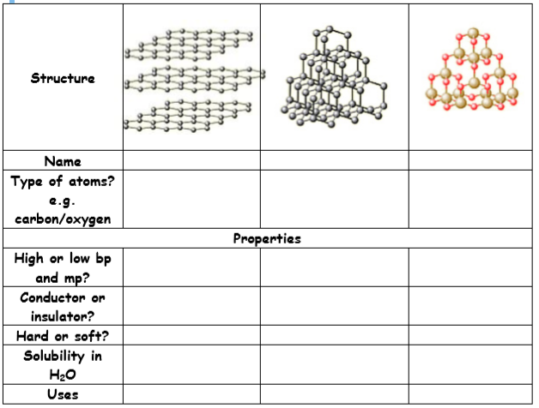
Topic 5 – Inorganic chemistry
Acids and alkalis play a crucial part in our everyday lives. Indigestion caused by excess stomach acid is neutralised by alkali in Gaviscon. Our breathing is controlled by the pH of our blood. Bee stings contain formic acid, which can be neutralised by bicarbonate of soda.
- Complete the following sentences
Acids have a pH of _______ than 7. Solutions of acids contain the _________ ion.
Alkalis have a pH of ______ than 7. Solutions of alkalis contain the _________ ion.
Neutral substances have a pH of ______.
2) Complete the following equations
Acid + Metal → _____________ + ____________
Acid + Metal Oxide → _____________ + ____________
Acid + Metal Hydroxide → _____________ + ____________
Acid + Metal Carbonate → _____________ + ____________+ _______________
Redox
1) What is “redox”?
___________________________________________________________________
2) Give an example of useful redox reactions in everyday life (there are millions!).
___________________________________________________________________
3) What does oxidation mean?
___________________________________________________________________
4) What does reduction mean?
___________________________________________________________________
5) Which element is oxidised and which is reduced in the reaction below?
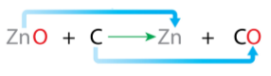
Oxidised ________________________ Reduced ________________________
6) Write the ionic equation for the following redox reaction:
copper sulfate solution reacting with magnesium to make magnesium sulfate and copper
___________________________________________________________________
___________________________________________________________________

Topic 6 – Organic chemistry
Organic chemistry is the chemistry of carbon compounds. Carbon forms a vast number of compounds because it can form strong covalent bonds with itself. This enables it to form long chains (up to 5000 in length) of carbon atoms, and hence an almost infinite variety of carbon compounds are known.

- What is a homologous series?
___________________________________________________________________
- What is the general formula for alkanes?
___________________________________________________________________
- Deduce the molecular formula of the alkane that has 13 carbon atoms per molecule.
___________________________________________________________________
- Give a test for alkenes.
___________________________________________________________________
___________________________________________________________________

Topic 7 – Rates of reaction
- What is meant by rate of reaction, and give example units.
___________________________________________________________________
- What is activation energy?
___________________________________________________________________
- Give 4 factors that affect the rate of reaction.
___________________________________________________________________
- Explain the effect of concentration on rate of reaction.
___________________________________________________________________
___________________________________________________________________
___________________________________________________________________

- Complete the table below
Effect: | On collision frequency | On collision energy | On activation energy | On number of successful collisions | On rate
Increase concentration
(liquids and gases)
Increase pressure (gases)

Increase temperature

Add a catalyst

6. A student investigated how temperature affects the rate of reaction between magnesium carbonate and dilute hydrochloric acid.

(a) Explain why the contents of the conical flask lose mass.
__________________________________________________________________
__________________________________________________________________

(b) The table below shows the student’s results for hydrochloric acid at 30 °C.
Time in seconds | Loss of mass in grams
0 | 0.00
20 | 0.26
40 | 0.48
60 | 0.67
80 | 0.82
100 | 0.91
120 | 0.96
140 | 0.99

Plot the data from the table above on the graph. Draw a line of best fit.

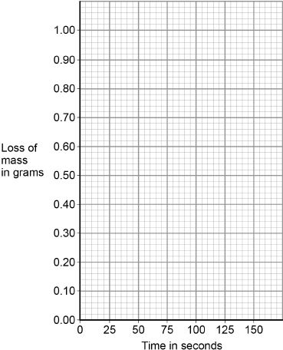(3)

The figure below shows the student’s results for hydrochloric acid at 50 °C

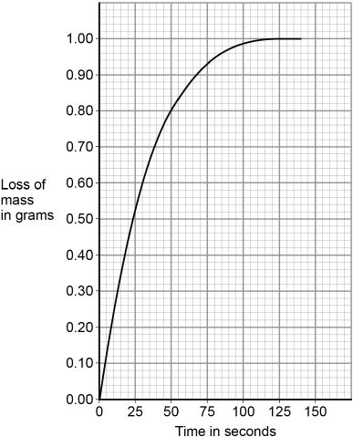

(c) Determine the rate of reaction at 50 °C when the loss of mass is 0.95 g

Show your working on the Figure above. Give your answer to 2 significant figures.
__________________________________________________________________
__________________________________________________________________
__________________________________________________________________
__________________________________________________________________
__________________________________________________________________
__________________________________________________________________

Rate of reaction = _____________________ g/s (4)

Task 8 - Flip learning
Flip learning is you looking at and researching a topic before we do it in class, so that you come to the lesson with a basic knowledge, which we can then deepen.
Research these Chemistry topics, and produce a 50 word (for each topic) summary (or diagram) of what you found:
- Ionisation energy
- Use of haloalkanes and their effect on the environment

