Muscular System Revision Guide

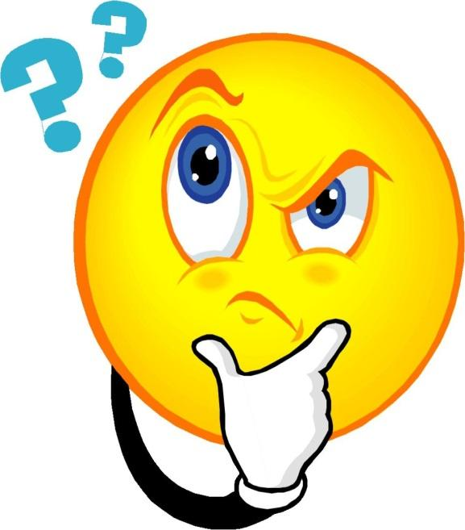
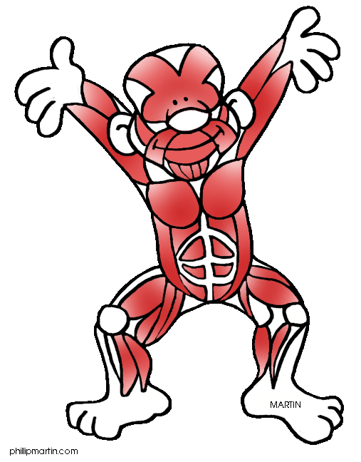

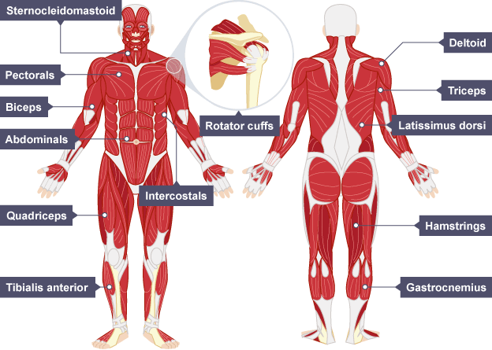
Voluntary Muscles
Muscle Name | Function | Sporting Examples
Sternocleidomastoid | Aid the breathing process. | All endurance events (1,500m).
Deltoid | Abduction of the shoulder. | Outward arm in a jumping jack.
Rotator Cuffs | Stabilises the shoulder preventing dislocation. | Throwing a javelin.
Pectorals | Adduction of the shoulder. | Upwards phases of a press up.
Intercostal | Assists with the breathing process. | All endurance events (1,500m).
Triceps | Extension of the elbow. | Shooting in netball.
Biceps | Flexion of the elbow. | Drawing a bow in archery.
Abdominals | Flexion of the trunk across the stomach (Sitting up). | Performing a sit up.
Latissimus Dorsi | Adduction of the shoulder. | Butterfly stroke in swimming.
Quadriceps | Extension of the knee. | Kicking a football.
Hamstrings | Flexion of the knee. | Performing a hamstring curl on a weight machine.
Gastrocnemius | Plantar flexion of the ankle. | Standing on tiptoes to mark a goal shoo in netball.
Tibialis Anterior | Dorsiflexion of the ankle. | Foot making contact with a football when passing.

Muscle Movement

CONCENTRIC CONTRACTION (ICC) – This involves the muscles shortening. The ORIGIN and INSERTION of the muscle move closer together and the muscle becomes FATTER.

.

ISOTONIC ECCENTRIC CONTRACTION (IEC) – This involves the muscle LENGTHENING whilst it is under tension. The ORIGIN and the INSERTION move further away from each other. An eccentric contraction provides the control of a movement on the downward phase and it works to resist the force of gravity.

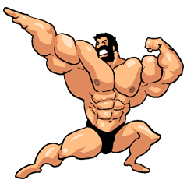
ISOMETRIC CONTRACTIONS - This involves a muscle producing tension but staying the same length. This occurs when the body is fixed in one position.

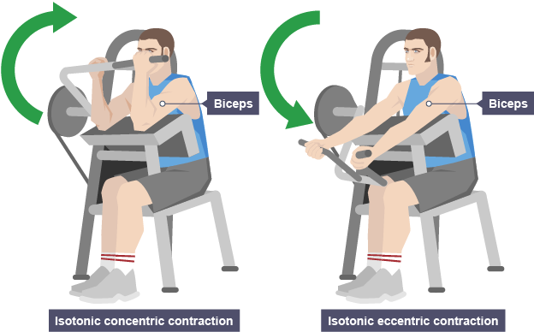
Muscle Movement
Right: Eccentric contraction - the biceps are contracting eccentrically to lower the weights against resistance
Left: Concentric contraction - the biceps are contracting concentrically to move the weights upwards.

ISOMETRIC CONTRACTION - The muscles are contracting isometrically to hold this gymnast in the crucifix position and are not changing length. When the isometric contractions end, isotonic contraction will occur.

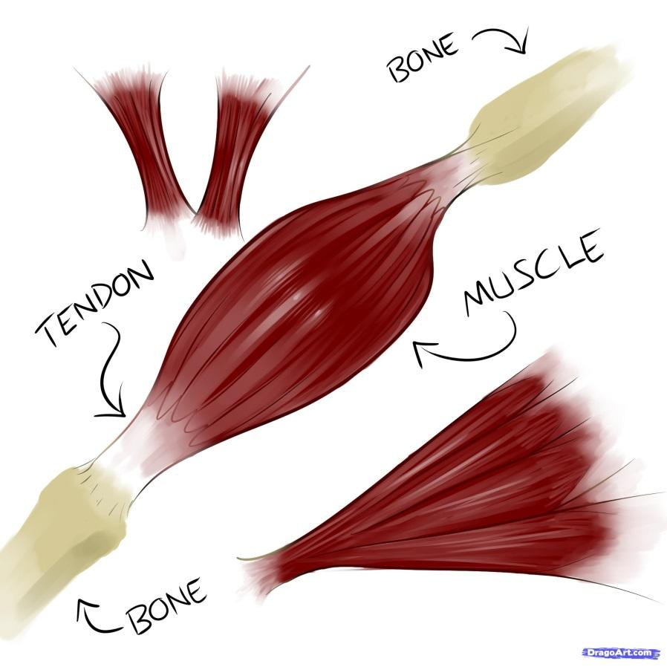
Muscle Pairs

Muscles transfer force to bones through tendons. They move our bones and associated body parts by pulling on them – this process is called muscle contraction.

Muscles work in ‘antagonistic muscle pairs’. One muscle of the pair contracts to move the body part, the other muscle in the pair then contracts to return the body part back to the original position. Muscles that work like this are called antagonistic pairs.

In an antagonistic muscle pair as one muscle contracts the other muscle relaxes or lengthens. The muscle that is contracting is called the agonist and the muscle that is relaxing or lengthening is called the antagonist.

Muscle Pairs
When you perform a bicep curl, the biceps will be the agonist as it contracts to produce the movement, while the triceps will be the antagonist as it relaxes to allow the movement to occur.

The biceps contracts and raises the forearm as the triceps relaxes.

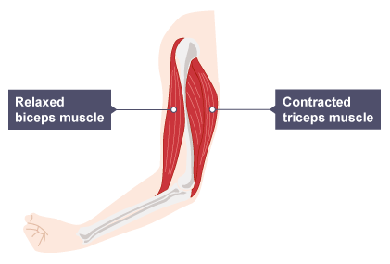
The triceps contracts and lowers the forearm as the biceps relaxes.

The Following groups of muscles are antagonistic pairs.
Muscle Pairs

BICEPS | TRICEPS
HAMSTRINGS | QUADRICPES
GLUTEALS | HIP FLEXORS
GASTROCNEMIUS | TIBIALIS ANTERIOR
PECTORALIS MAJOR | LATISSIMUS DORSI
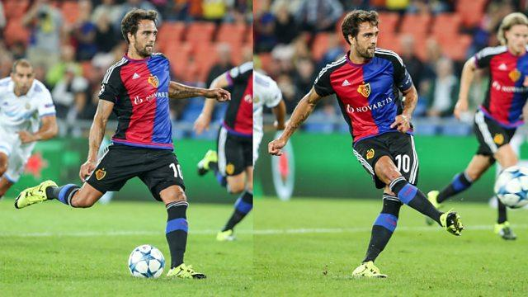

In the preparation phase, when a footballer prepares to kick a football, their hamstrings contract to flex the knee while the quadriceps lengthens to allow the movement. The hamstrings are the agonist and the quadriceps are the antagonist.
In the striking and recovery phase, the quadriceps contract to extend the knee while the hamstrings lengthen to allow the movement. The quadriceps are the agonist and the hamstrings are now the antagonist.

Quick Questions
Which muscle group acts as a fixator at the shoulder to stabilize the joint during movement?
Biceps
Triceps
Deltoid Rotator cuff

During movement what action is being taken by the antagonist?
Shortening
Lengthening
Staying the same length

Which of these muscles contracts in increase the capacity of the lungs during breathing in when exercising?
Deltoid
Abdominals
Sternocleidomastoid

Which muscle group contracts to cause horizontal flexion during a punch in boxing?
Pectorals
Deltoid
Latissimus Dorsi

Which muscle group is responsible for flexion at the knee when a footballer prepares to kick a football?
Quadriceps
Gluteus Maximus
Hamstrings

When a player shoots at the goal in netball, the gastrocnemius contracts to provide which movement at the ankle?
Dorsiflexion
Plantar Flexion
Extension

Which type of muscle contraction is completed by the triceps during the upwards phase of a press up?
Isometric
Concentric
Eccentric

Which of the following sporting examples would involve isometric contractions of the quadriceps?
A gymnast landing after a vault
A sprinter in the “set” position
A netballer jumping to catch

Which muscle operates as the antagonistic pair in combination with the hip flexors?
Gluteus Maximus
Hamstrings
Quadriceps

Which structure connects muscles to bones and allows force to be transmitted from the muscle to move the skeleton?
Ligament
Cartilage
Tendon

Deltoid Rotator Cuff
Lengthening
Sternocleidomastoid
Pectorals
Hamstrings
Plantar Flexion
Concentric Contraction
A sprinter in the ”set” position
Gluteus Maximus
Tendon
Answers

