Skeletal System Revision Guide

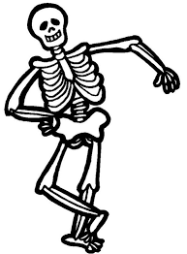

Structure of the skeletal system

Types of Bones
Within the skeleton there are different kinds of bone. The type of bone determines the amount of movement.

Type Of Bone | Example Of Bone | Function Of Bone
Long | Femur/Humerus | Movement – to generate speed or strength
Short | Carpals/Tarsal | Shock absorption – spreading body load.
Flat | Ribs/Cranium | Protection of vital organs, attachment of muscles to help movement
Irregular | Vertebrae | Provide shape, protection
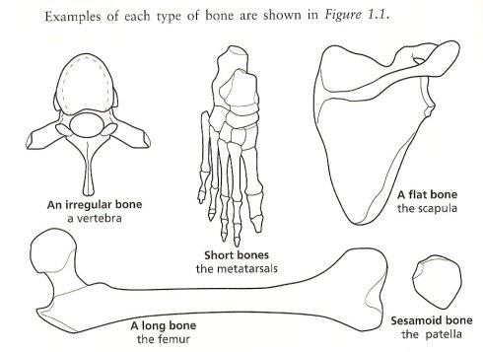

Functions of Bones

6 Functions

Support

Protection

Production of Blood Cells

Structural Shape

Mineral Storage

Movement

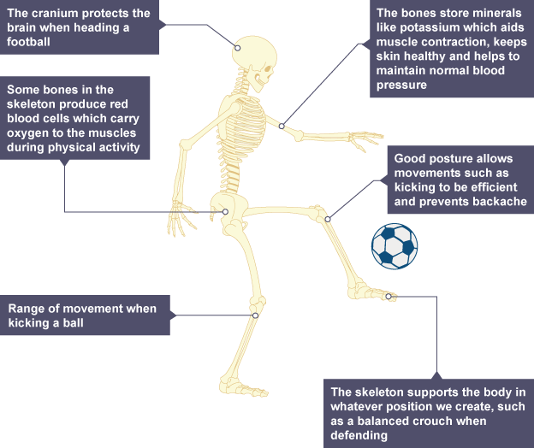
Functions of Bones

.

Name | Function Purpose
Movement | The skeleton allows movement of the body as a whole and its individual parts. The bones act as levers and also form joints that allow muscles to pull on them and produce joint movements.
Support | The skeleton keeps the body upright and provides a framework for muscle and tissue attachment.
Protection | The bones of the skeleton protect the internal organs and reduce the risk of injury on impact. For example, the cranium protects the brain, the ribs offer protection to the heart and lungs, the vertebrae protect the spinal cord and the pelvis offers protection to the sensitive reproductive organs.
Production Of Blood Cells | Certain bones in the skeleton contain red bone marrow and the bone marrow produces red blood cells, white blood cells and platelets. Examples of bones that contain marrow are the pelvis, sternum, vertebrae and clavicle.
Mineral Storage | The bones themselves are made of minerals and act as a mineral store for calcium and phosphorous, which can be given up if the body requires the minerals for other functions.
Structural Shape | The skeleton provides the human shape and determines the height of a person.
Joints

A joint is a place where two or more bones meet and is also called an articulation.

The role of joints and connective tissue
Connective tissues consist of ligaments, cartilage and tendons.
A joint is held together by ligaments which give the joints their stability.
Cartilage is found at the ends of bones and where joints meet.
Tendons attach muscles to the skeleton.

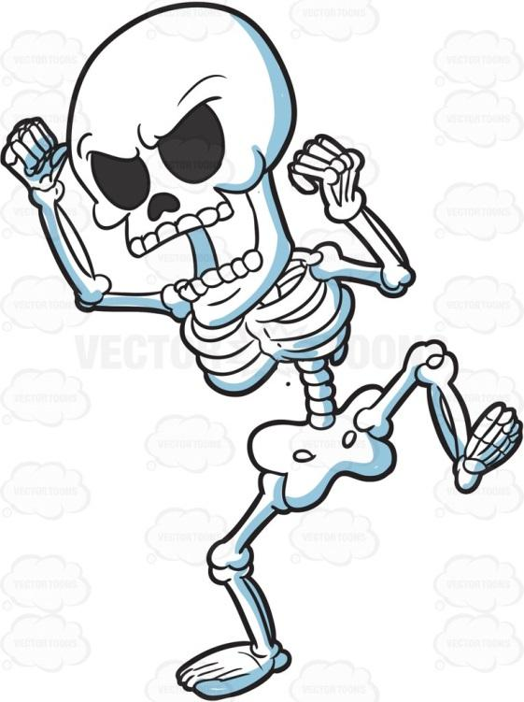

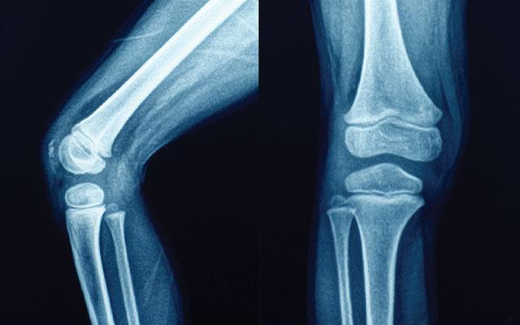
Synovial Joints
In synovial joints, the ends of the bones are covered with cartilage which cushions the joint and prevents friction and wear and tear between the bone ends. Cartilage is a soft, spongy connective tissue it prevents wear and tear on the bones.

Synovial joints (freely movable joints) allow us the free movement to perform skills and techniques during physical activity.
Synovial joints have synovial fluid in the joint cavity that lubricates or 'oils' the joint so it moves smoothly. Synovial fluid is made by the synovial membrane.

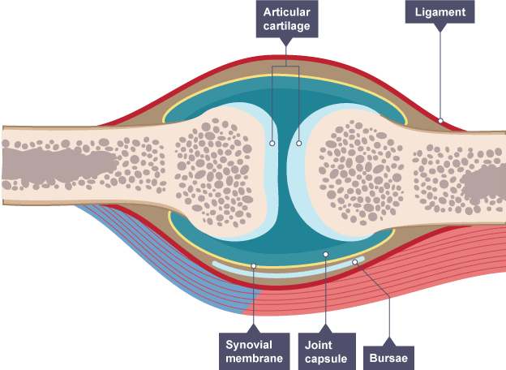

The bones in a synovial joint are connected by ligaments, which:
1) A type of connective tissue and are tough, fibrous and slightly elastic
2) Connect bone to bone and help keep the joint together
3) Stabilise the joints during movement and prevent dislocation by restricting actions outside the normal joint range
4) Can absorb shock because of their elasticity, which protects the joint
5) Help maintain correct posture and movement
Synovial Joints
The movement at a synovial joint is caused by the muscles attached across the joint. Muscles are attached to bone by tendons. Tendons are very strong, inelastic connective tissues that allow a muscle to pull on a bone to move it.

Name of Synovial Joint | Location and Function
Ball and Socket | Found in the shoulder and hip. This joint allows for the greatest range of movement.
Hinge | Found at the elbow and knee. The range of movement is limited to one plane.
Condyloid | Found at the wrist and ankle. Movement in two planes.
Pivot | Found in the neck. Part of the bone fits into another ring of bone.
Saddle | Found at the base of the thumb. This joint allows movement in two directions.
Gliding | Found in the wrist and veritable column. Two bones have a small range of movement limited by connected ligaments.

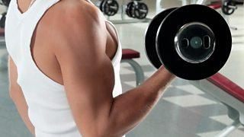
Types of Joint Movement
The different types of movement that are permitted at each joint are described below.

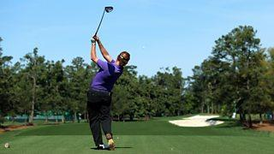

Flexion | Bending a joint. This occurs when the angle of a joint decreases. For example, the elbow flexes when performing a biceps curl.
Extension | Straightening a joint. This occurs when the angle of a joint increases, for example, at the elbow when putting a shot.
Abduction | Movement away from the midline of the body. This occurs at the hip and shoulder joints during a jumping jack movement.
Adduction | Movement towards the midline of the body. This occurs at the hip and shoulder, returning the arms and legs back to their original position from a jumping jack movement.
Rotation | This is where the limb moves in a circular movement around a fixed joint towards or away from the midline of the body. This occurs in the hip in golf while performing a drive shot.
Plantar Flexion | Pointing the toes – this movement only occurs at the ankle, for example, pointing the toes in ballet
Dorsiflexion | The foot moves towards the shin as if you are pulling your toes up. This movement only occurs at the ankle.
Revision Tasks
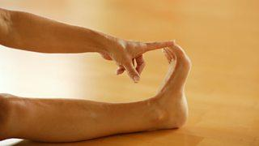
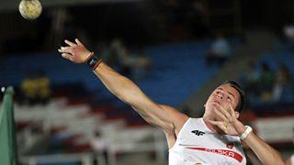
[Type a quote from the document or the summary of an interesting point. You can position the text box anywhere in the document. Use the Drawing Tools tab to change the formatting of the pull quote text box.]
Quick Questions
Which gel like substance helps to lubricate the movement of joints?
Articular Cartilage
Bursae
Synovial Fluid

Which two bones connect at the shoulder?
Scapula and Sternum
Scapula and Humerus
Humerus and Sternum

What types of bones, such as carpals are designed for strength and weight bearing?
Irregular bones
Long bones
Short bones

In which part of a bone are blood cells produced?
Bone marrow
Ends of bones
Cartilage

Which function of the skeleton is most relevant during a powerful tackle in rugby?
Protection
Mineral storage
Blood cell production

Which type of connective tissue helps to stabilise the ankle joint during the dynamic movement of a badminton match?
Articular cartilage
Synovial fluid
Ligaments

Which of the following joints is an example of a hinge joint?
Hip
Shoulder
Ankle

Which kind of joint movement describes the movement of a limb in a circle around a fixed point such as the action of the hip in a golf drive?
Flexion
Extension
Rotation

Which of these movements only occurs at the ankle?
Plantar Flexion
Adduction
Extension

Which type of joint allows for flexion, extension, abduction and adduction?
Pivot
Hinge
Ball and socket

Synovial Fluid
Scapula and humerus
short bones
Bone marrow
Protection
Ligaments
Ankle
Rotation
Plantar flexion
Ball and socket
Answers

