Y12 Business Studies- Bridging Work

Exam Board: Pearson Edexcel
Specification: BTEC Level 3 National Extended Diploma in Business
Textbooks to purchase:
Pearson BTEC National Business Student Book 1 (ISBN 9781292126241 & Book 2 (ISBN 9781292126258)

In Year 12 Business Studies, you will be studying:

Unit of Work | Learning Aims
Unit 1 Exploring Business | A. Explore the features of different businesses and analyse what makes them successful  B. Investigate how businesses are organised  C. Examine the environment in which businesses operate  D. Examine business markets  E. Investigate the role and contribution of innovation and enterprise to business success.
Unit 2 Developing a Marketing campaign | AO1 – Demonstrate knowledge and understanding of marketing principles, concepts, processes, key terms, data sources and definitions.  AO2 – Analyse marketing information and data, demonstrating the ability to interpret the potential impact and influence on marketing campaigns.  AO3 – Evaluate evidence to mark informed judgements about how a marketing campaign should be planned, developed and adapted in light of changing circumstances.  AO4 – Be able to develop a marketing campaign with appropriate justification, synthesizing ideas and evidence from several sources to support arguments.
Unit 3 Personal and Business Finance (External Exam) | AO1 – Demonstrate knowledge and understanding of business and personal finance principles, concepts, key terms, functions and theories  AO2 – Apply knowledge and understanding of financial issues and accounting processes to real-life business and personal scenarios  AO3 – Analyse business and personal financial information and data, demonstrating the ability to interpret the potential impact and outcome in context  AO4 – Evaluate how financial information and data can be used, and interrelate, in order to justify conclusions related to business and personal finance
Unit 14 Investigating Customer service | A: Explore how effective customer service contributes to business success  B: Investigate the methods used to improve customer service in business  C: Demonstrate customer service in different situations, using appropriate behaviours to meet expectations.

The activities below have been carefully designed for you to develop your knowledge and understanding in all the units that you are going to study.

Task 1:
Pick a marketing campaign you have found (this could be from a newspaper, a website or a TV advert) and create a PowerPoint presentation that answers the following points:

What are they selling?
Who do you think their target market is
Why have they marketed it in this way?
Have they attracted the target market and how?
How effective is the marketing campaign and why?

This presentation is due on your first Business lesson and will be shared with the class.

Task 2:
Unit 3: Personal and Business Finance is an externally assessed unit failure to pass this unit would mean you will not achieve the full award Investigate the following: Give two features of a premium current account. Describe the role of the Financial Ombudsman Service. Explain two benefits of pre-paid credit cards of the type used when on holiday. Household debt is at its highest level in a decade. Many families are struggling to pay back money they have borrowed. Shekemi has recently taken out a loan for a new car but is worried that she might not be able to keep up the repayments.

• Discuss why it is important for Shekemi to avoid getting into unmanageable debt.

Over the last 5 years, interest rates have been at a consistently low level. More savers are looking to alternative methods of saving.

• Assess the use of Premium Bonds as a method of saving.

Task 3:
Connor's business Connor has recently taken over the family cheese-making business after his mum decided to retire. The business has been very successful recently and has been featured on several 'real food' programmes on television as well as securing a two-year deal with a national supermarket chain. Connor is looking to expand the business. You have been hired by Connor to help with the financial side of the business and to take the lead on the expansion. Businesses such as Connor’s will have assets.

-Identify two types of intangible non-current assets. -Outline what is meant by ‘capital income’. Connor has given you his gross profit figure of £613,843 but having carried out a stocktake you notice his closing inventories figure has changed from £48,794 to £49,102.

- Calculate Connor’s new gross profit figure.
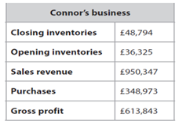
- Calculate the inventory turnover. Connor has given you the rest of the figures for the statement of comprehensive income. However, when you check his figures you notice that he has missed the following information: electricity of £858 is outstanding wages of £1,211 have been paid in advance the motor vehicle is to be depreciated by 15% using the reducing balance method. Using your gross profit figure from part (a), calculate Connor's profit or loss for the year.
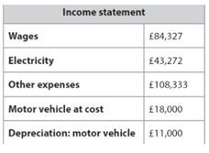

Task 4
Write a report explaining the key features of a business that is local to you. The business you choose should be a small business that is local to where you live. It could be somewhere that you often shop or somewhere that interests you. Examples of the types of business you may wish to choose are:
- Any local shop
- A cafe
- A market stall on Church Street
- A dry cleaners
- A hairdresser
- A charity shop

Ideas of places to collect your research:
- Visit the business
- Use your experiences as a customer at the business
- Chat to the owner
- Talk to any employees
- Chat to other customers to see their experiences
Research online:
- Use Google
- See if your business has a website
- Find customer review sites online
- Research any competitors of the business

Potential Report Plan:
Introduction
- Introduce the business
- What does the business sell/provide?
- Why did you choose that specific business?
Main Body
- This section can be directed by you based on the research you find.
- Go through the new definitions you have discovered and see which key features your business has.
- Make sure you include the definition and an example of how they use it.
- You may wish to include some information you find about key business terms that you have found on your own. That is great.
- You could also compare your business with a different business to see how they are similar/different.
Conclusion
- Sum up your key findings and anything else you would like to know if you were to do more research

References
- If you do any online research, make sure you include the website so we can see where the information came from.

Task 5
Instructions:
Read the article.

Create a presentation on the article.
Create a presentation around your topic. Your presentation should include:
- A background of the issue your discussing
- What is happening in the news right now with your issue
- Research about the key questions considered
- Your opinions on some of the important questions
- How the issue affects businesses
- You should also carry out further research around the topic you have chosen using the suggested google searches and key questions to consider.

You will be presenting back your findings when we meet in September

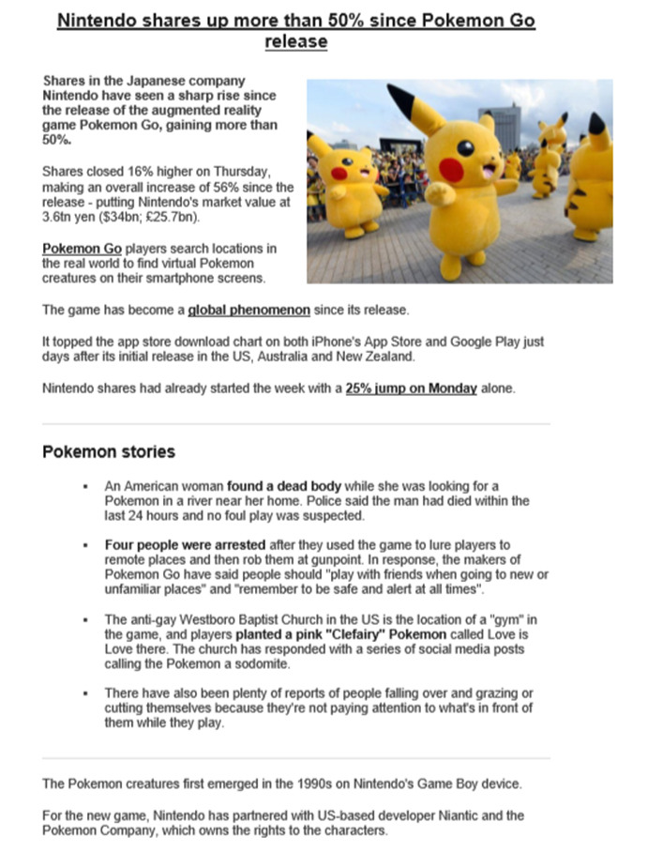

https://www.bbc.co.uk/news/business-36791275

Key Questions:

- What type of business is Nintendo in?
- How successful have Nintendo been over the years?
- What is Pokemon?
- How much is Nintendo worth?
- How important is technology to Pokemon’s recent success?

Potential Google Search Ideas

- Pokemon Go
- Nintendo share value
- Pokemon phenomenon
- Nintendo gaming
- Game boy

Essential Wider Reading and Checklist

Independent learning (online resources and TV programmes to watch)
Annual reports service
Order free annual reports from the Financial Times. Often useful to illustrate issues regarding strategy, the role of directors, factors that affect performance of the business. Shows the different ways organizations present themselves whilst also highlighting the reporting responsibilities of public companies – you might be surprised by how much data there is in these.
http://ftcom.ar.wilink.com/asp/ P002_search_ENG.asp
Bank of England
A good site that explains what the Bank of England does and what is meant by monetary policy and the links between interest rates and inflation. Useful for Unit 4.
http://www.bankofengland.co.u k/
BBC News A superb resource and one of the best starting points to find resources.
http://news.bbc.co.uk/1/hi/busi ness/
Competition Commission
The Competition Commission is an independent public body that conducts in depth inquiries into mergers, markets and the regulation of the major regulated industries. You can see what it is currently investigating on its current inquiries section.
http://www,competitioncommission.org.uk/
European Union The official site for information on the European Union.
http://europa.eu/
Fortune Website of the famous magazine that includes the top 500 companies in the world, the most powerful business people and the 100 best companies to work for.
http://money.cnn.com/magazin es/fortune/
Federation of Small Businesses
The organisation that represents many small businesses in the UK. The site has information on the issues currently concerning small business owners.
http://www.fsb.org.uk/
Statistics Free access to data produced by the Office for National Statistics and government departments. Everything from baby names, productivity, employment, inflation, share ownership and how people spend their time.
http://www.statistics.gov.uk/

Essential Wider Reading and Checklist

Independent learning (online resources and TV programmes to watch)
Statistics (how to make sense of) can be downloaded and included in your projects, free of charge.
Stats4schools is about helping you to get more from statistics. There are datasets that
http://www.stats4schools.gov.u k/
Tom Peters Access the website of this expert on business management practices.
http://www.tompeters.com/
Times 100 A resource centre for business studies and Economics students. The material is centred on well-known businesses covers all the key topic areas. Case studies, theory, quizzes, company information links (taking you to specific sections of the featured company website), etc..
http://www.thetimes100.co.uk
Tutor2u Excellent website. Offers free student resources including revision notes and quizzes.
http://www.tutor2u.net/
You Tube Online videos - always worth searching for a clip on the topic you are studying.
http://www.youtube.com/
Bank of England
A good site that explains: what the Bank of England does and what is meant by monetary policy and the links between interest rates and inflation. Useful for Unit 4.
http://www.bankofengland.co.u k/
BBC News A superb resource and one of the best starting points to find resources.
http://news.bbc.co.uk/1/hi/busi ness/
British Franchise Association
“The British Franchise Association is the voluntary self-regulating governing body for franchising.” This site features useful information on awards and case studies. Helpful for Unit 1.
http://www.thebfa.org/ http://www.thebfa.org/casestud ies.asp
Business in the Community
“Business in the Community is a membership of companies with the leadership to translate corporate values and commitments into mainstream management practice. These companies measure and report on progress and illustrate the action being taken to improve the impact of their operations, products and services on society and the environment.” This website has useful case studies and statistics.
www.bitc.org.uk

Films:
Kinky Boots (2012) (12)
Moneyball (2011) (12A)
POM Wonderful Presents: The Greatest Movie Ever Sold, 2011
Jobs, 2013

Transition to BTEC Business checklist - will you be ready in September?

Item / task | Completed?
Complete summer transition tasks 1-5

Buy textbooks / subject specific books for term 1

Buy folders / dividers for each subject

Download the specification for each unit and familiarise yourself with the outline of each course and the AOs.

