A-level English Language
Bridging Work
Are you ready for English Language A-level?
English Language is relevant to YOUR life. It is the study of how language influences views on gender, age, class, race, regional accents and dialects and the big issues we are facing today. You will analyse how language and representations have changed over time and how new words become incorporated into our vernacular. The study of English Language gives you the power to critique texts and to make up your own mind – you will study Tweets, podcasts, interviews, adverts and things you didn’t even realise were texts! You will become a language investigator.
Child language acquisition enables you to study how children learn to read and write. It is still not fully understood how the brain learns language and you will have the opportunity to apply competing theories to transcripts of child spoken and written language. You decide which theories are the most useful and why.
Having studied language use, you now need to put this into practice with your own original writing. You will study the power of persuasion, the power of storytelling and the power of information. Creative and persuasive writing forms a substantial part of your exam and coursework. The coursework element provides the opportunity to delve deeper into the work of writers you admire and the topics you feel most passionately about. You can focus on elements of the course that are compatible with your other subjects and future career plans whether in journalism, law, creative writing, speech and language therapy, teaching, sociology or many other areas.
The following five tasks have been designed to prepare you for your A-level. By completing all five tasks you will develop your opinions in key topics and debates in English Language. You will also look at what makes your personal language unique and learn key terminology in advance. You can fill in your answers on this document or in a separate document. Alternatively, you may choose to present your work in a different way such as in PowerPoint or on paper.

TASK 1: Sociolinguistics: Pick three articles to read from the list following the table and fill in the table below.
Article / YouTube Video / Podcast title | Ex. Article: Why do people, like, say, ‘like’ so much? | 1. | 2. | 3.
Who produced the text and who do you think is their target audience? | Sam Wolfson – journalist for The Guardian / Observer.  Written for readers of The Guardian / Observer; People interested in Language and gender and politically right leaning readers who dislike prescriptive views of language.
Summarise the main message(s) in the text? | Despite the use of ‘like’ being viewed as ‘lazy’ and used predominantly by young women, the message is that it is a lot more complex than that, with some studies showing that people who use ‘like’ are more intelligent than those who don’t and that men use it some contexts more than women.
What did you find most interesting in the article and why? | The advice to teachers that they shouldn’t criticise students’ way of speaking as this can be ‘very harmful’. Many teachers I know disagree with this so I was interested to hear the other side.

LANGUAGE AND GENDER
https://theconversation.com/amp/shrill-bossy-emotional-why-language-matters-in-the-gender-debate-158310?utm_source=twitter&utm_medium=bylinetwitterbutton&__twitter_impression=true&s=09
The use of ‘like’: https://www.theguardian.com/science/2022/may/15/why-do-people-like-say-like-so-much-in-praise-of-an-underappreciated-word?CMP=share_btn_tw&s=09

LANGUAGE AND ACCENT
http://news.bbc.co.uk/1/hi/uk/7329768.stm
https://www.theguardian.com/education/2020/oct/24/uk-top-universities-urged-act-classism-accent-prejudice?CMP=Share_AndroidApp_Other&s=09
https://www.independent.co.uk/voices/accent-discrimination-work-job-prejudice-b1399561.html

NEW TERMINOLOGY (Coinage): “woke”
https://www.kcl.ac.uk/news/public-split-on-whether-woke-is-compliment-or-insult-and-unsure-what-culture-wars-means-despite-huge-surge-in-media-coverage?s=09

EXPLETIVES

Video: Language Varieties: Swearing in Spoken English and English as a Global Language

https://amp.theguardian.com/science/2021/jun/10/swearing-on-rise-but-parents-still-dont-want-kids-hearing-it-report-finds?CMP=Share_AndroidApp_Other&__twitter_impression=true&s=09

LANGUAGE AND RACE
https://www.cambridge.org/core/journals/language-in-society/article/white-ears-of-ofsted-a-raciolinguistic-perspective-on-the-listening-practices-of-the-schools-inspectorate/E6ECBB4A5DDE794CD44270C67CAEDF19#.YjTP1lOxeFc.mailto

Podcast – Various topics
https://podcasts.google.com/feed/aHR0cHM6Ly9hbmNob3IuZm0vcy8xZmI1YTFhYy9wb2RjYXN0L3Jzcw?sa=X&ved=0CAMQ4aUDahcKEwiIjunnmaj4AhUAAAAAHQAAAAAQAQ&s=09

TASK 2: Idiolect and familect
Understanding your own language
All people who speak words aloud do so with an accent and a dialect.
‘Accent’ is the term we use to describe the way the words we speak aloud sound, usually (but not always) depending on where someone was when they learnt that particular language. For example, you might comment on somebody’s American accent, and how it sounds different when they say the word ‘mother’.
‘Dialect’ is the word that we use to describe the actual vocabulary choice that someone has made to label something or someone. For example, dialectal variations of ‘mother’ could be ‘mam’, ‘mum’, ‘mom’, ‘ma’ or even ‘maw’. Or, thinking about America still, they will walk on a sidewalk, instead of a pavement, and get water from a faucet, rather than a tap.
There are many thousands of words that have dialectal varieties, and you use these, and other words that you have learnt from your own personal experience of the world to create your own personal language, unique to you. This is called your idiolect. Everyone’s idiolect is different, because no two people have had the exact same experience of the world.

My Idiolect Investigation
Using the table below, add in the word that YOU personally would use to label the thing being described. A short description has been provided for you. Some of these are designed to work out your dialect, others are looking into your idiolect.
Item | What do you call it?
A bread item that you would put a sausage/burger in at a barbeque
What someone with long hair would use to put it into a ponytail. It is stretchy and made from elastic.

Footwear that is worn for physical activity. They are normally white.

A human that was born in the last 6 months
The collective word for a group of your friends
A word you would use to describe something really good
A word you would use to describe somebody who was very drunk
A word you would use to describe yourself if you were very hungry.

My Familect Investigation
Somewhere in between your personal idiolect and the dialect of the area you live in, you will also have a familect. This is the language that you use within your family, and may contain in-jokes, words and other stories that would not be understood by other people.
Have a read at this article to get a better understanding of the term.
https://www.theatlantic.com/family/archive/2021/05/family-secret-language-familect/618871/
Now, reflect on your own language. What words or phrases do you use within your family that other people might struggle to understand? It might be useful to talk about this with those you live with to help you remember any special words or phrases.
I’ve given an example from my own personal familect. Can you work out what it means?
Word + word in a sentence | What does this mean?
Example: ‘Pappy’  All the bread at the supermarket was pappy. | Have a guess – what do you think this means?
Your example 1:
Your example 2:
Your example 3:
Optional:

TASK 3:
Genre refers to the style or category of a text, eg blog post, text, children’s story, advert, fiction writing, article, Tweet, gothic, jazz
Audience refers to the reader(s). This could be an individual, in the case of a text message, or a broader group of people in the case of a magazine article or blog.
Purpose refers to the reason for the writing, e.g. to persuade the reader, to entertain them, to share information, to warn, to advise, to explain. Texts can have more than one purpose – the primary purpose (what the main purpose of the text is) and the secondary purpose (another, less important, purpose.)
Mode refers to the manner with which the ‘text’ is communicated, e.g. spoken or written.
Have look over the texts below. What Genre, Audience, Purpose and Mode do they have? Put your ideas into the table. Can you provide evidence to support what you’re saying?

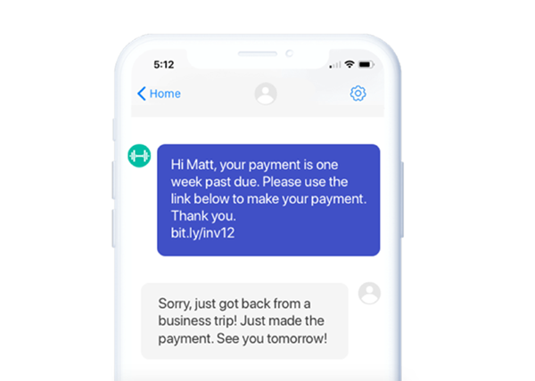
TEXT A:

TEXT B:
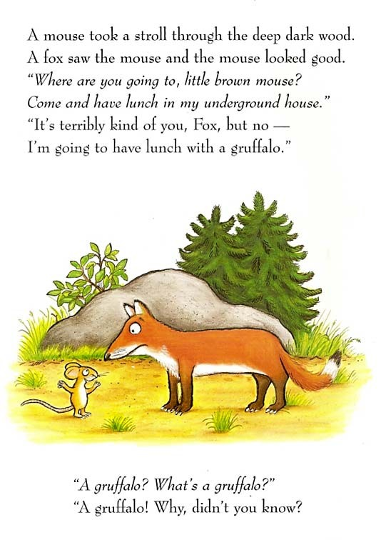
TEXT C:
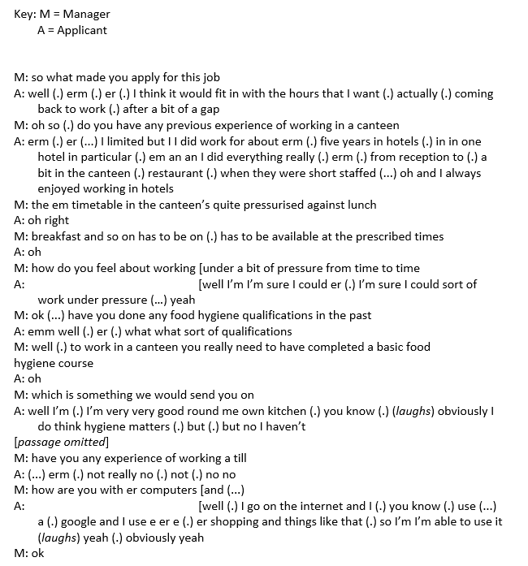

 | Genre | Audience | Purpose | Mode
TEXT A
TEXT B
TEXT C

Now, have a look around your home. Find 3 more texts that have been written for different purposes, audience, genres or are communicated through different modes. Make sure you put a description of each text in the Text column
Analyse your examples using the grid below:
Text | Genre | Audience | Purpose | Mode

TASK 4: Find a newspaper article / advert / blog post / Twitter post that stands out to you. It can be about anything! There are some ideas for you at the end of this document if you are stuck.
Answer the following questions in the form of annotations, a PowerPoint presentation or a poster:
- Who produced this text?
- Where was it published?
- Who is the target audience?
- What groups of people / individual people / topics etc are represented in this text? Eg. The government, the producer of the text, teenagers, crime, school, rap music. The target audience
- How are they represented? Positively, negatively, as victims, as irresponsible, as trustworthy/untrustworthy…
- What language and or images are used to create these representations?

TASK 5: Write a blog post or newspaper article in which you argue something you feel passionate about. Aim for around 500 words.
Some ideas are:
- Pollution
- Politicians
- Sexism
- Racism in football
- Positive discrimination
- Salaries for certain jobs

Possible texts for TASK 3:

