A Level English Literature Bridging Work
Year 11 into 12
2023/2024

Read through the guidance and complete as many tasks as you can

For more info please speak to Mr Weetman, Mr Tansey, or Miss Turner.
AQA – English Literature A Level
“Books are mirrors and windows”
Studying literature allows us to understand more about human beings – why we do what we do, how we feel about the world and each other, how we succeed and how we fail, how we love and how we hate. Since humans first started to use language, we have told stories to help make sense of ourselves and of our world. They are a window into other lives and a mirror to our own.
In our first term we will read Othello, The Great Gatsby and a selection of Love Poetry. In Othello, we will see the effects of power and prejudice. We will discuss how racism and misogyny can destroy lives. We will see how toxic relationships and jealousy lead to unhappiness and ultimately tragedy.
With The Great Gatsby, we will gain an insight into lives of privilege and wealth. We will discuss society’s obsession with celebrity and money, and how privilege can lead to feelings of emptiness and unhappiness.
The Love Poetry we will read expresses the many aspects of love and relationships: the adoration of a loved one, the pain of separation, the difficulty of unrequited love and the joy of feeling close to another. There are poems about being faithful and about being unfaithful, about jealousy and about trust.
Studying literature is about understanding what a writer is trying to express, and then analysing the methods they use to convey their ideas and emotions. It is not just what they are trying to express, it is about how they express it, and why they have used particular methods. This analytical skill is widely acknowledged by universities and across wider society as crucial for success in a wide range of areas.
The following tasks and areas of research are designed to give you a taste of what to expect from the course, and to encourage you to think in a critical way about literature.

Task 1:
Watch the trailer for BAZ Luhrmann’s movie of The Great Gatsby - https://youtu.be/rARN6agiW7o
Write down what you think the story will be about? What themes do you think it will deal with? What do you think is the significance of the song ‘Love is Blindness’ playing over the trailer?
Task 2:
Do some online research and answer these questions:
What was The Jazz Age?
What was Prohibition in the USA and why did it fail?
Find a quote from F. Scott Fitzgerald about the character of Jay Gatsby.
Find out three things about the author of The Great Gatsby.
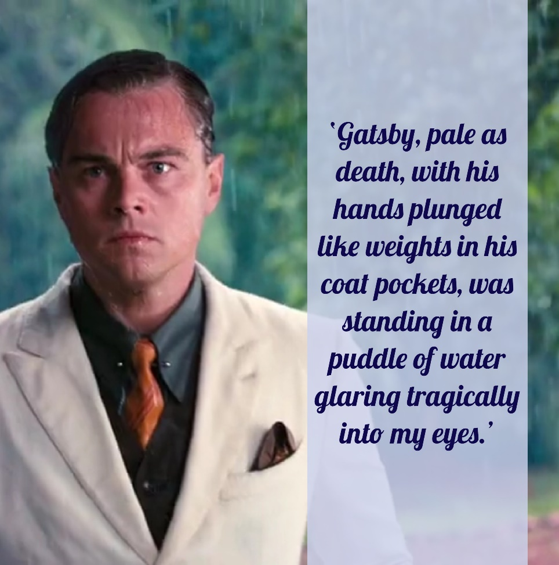

Task 3:
Read the following extract from the novel and answer the question set.
The Great Gatsby
This novel tells the story of Jay Gatsby’s unrequited love for Daisy Buchanan. In this extract, Gatsby has persuaded his neighbour Nick, to invite her for tea in the hope that Gatsby can win her back after five years of loving her from afar. Nick leaves Gatsby nervously waiting in the living room whilst he answers the door to Daisy.
We went in. To my overwhelming surprise the living-room was deserted. ‘Well, that’s funny,’ I exclaimed. ‘What’s funny?’
She turned her head as there was a light dignified knocking at the front door. I went out and opened it. Gatsby, pale as death, with his hands plunged like weights in his coat pockets, was standing in a puddle of water glaring tragically into my eyes. With his hands still in his coat pockets he stalked by me into the hall, turned sharply as if he were on a wire, and disappeared into the living-room. It wasn’t a bit funny. Aware of the loud beating of my own heart I pulled the door to against the increasing rain. For half a minute there wasn’t a sound.
Then from the living-room I heard a sort of choking murmur and part of a laugh, followed by Daisy’s voice on a clear artificial note:
‘I certainly am awfully glad to see you again.’ A pause; it endured horribly. I had nothing to do in the hall, so I went into the room. Gatsby, his hands still in his pockets, was reclining against the mantelpiece in a strained counterfeit of perfect ease, even of boredom. His head leaned back so far that it rested against the face of a defunct mantelpiece clock, and from this position his distraught eyes stared down at Daisy, who was sitting, frightened but graceful, on the edge of a stiff chair.
‘We’ve met before,’ muttered Gatsby. His eyes glanced momentarily at me, and his lips parted with an abortive attempt at a laugh. Luckily the clock took this moment to tilt dangerously at the pressure of his head, whereupon he turned and caught it with trembling fingers, and set it back in place. Then he sat down, rigidly, his elbow on the arm of the sofa and his chin in his hand. ‘I’m sorry about the clock,’ he said. My own face had now assumed a deep tropical burn. I couldn’t muster up a single commonplace out of the thousand in my head.
‘It’s an old clock,’ I told them idiotically. I think we all believed for a moment that it had smashed in pieces on the floor.
‘We haven’t met for many years,’ said Daisy, her voice as matter-of-fact as it could ever be.
‘Five years next November.’ The automatic quality of Gatsby’s answer set us all back at least another minute.

How does the writer use language to express Gatsby’s emotions in this extract?
Try to find FOUR quotations to analyse. The best answers will look at the quotations from different angles.
You can analyse word choice, similes/metaphors, sentence structure or any other technique you think is relevant.
Use the following sentence starters to help you.
In this extract, the writer creates a sense of……
In line…..the writer describes………
This suggests……
Furthermore, it may also relate to…….
This emphasises the sense of…….the writer is trying to achieve.

Task 4: Poetry
Read the following poem then complete the tasks. This requires independent study and research.

The Garden of Love
BY WILLIAM BLAKE
I went to the Garden of Love,
And saw what I never had seen:
A Chapel was built in the midst,
Where I used to play on the green.

And the gates of this Chapel were shut,
And 'Thou shalt not' writ over the door;
So I turn'd to the Garden of Love,
That so many sweet flowers bore.

And I saw it was filled with graves,
And tomb-stones where flowers should be:
And Priests in black gowns were walking their rounds,
And binding with briars my joys & desires.

Online research: The following articles and videos will help you answer the questions. You should look for other sources online as well: you can answer every question here with a bit of online searching.

https://interestingliterature.com/2018/01/a-short-analysis-of-william-blakes-the-garden-of-love/
https://www.litcharts.com/poetry/william-blake/the-garden-of-love

- What do you think the garden itself represents? What biblical allusion is there in this idea? Can you explain this fully?
- When was Blake writing?
- What were Blake’s views generally, and on organised religion in particular?
- In the light of these views, why is the chapel being ‘built’ in the garden significant?
- Write a paragraph that describes the meaning of this poem (200 -300 words).
- You should all have studied Blakes’ ‘London’ for GCSE. Write a paragraph comparing the two poems, and explaining how both reflect his views on society and organised religion.

