Summer Bridging Work: GCSE Science to Level 3 BTEC Applied Science

Applied Science Team: Ms Salim, Ms Jina, Ms Bourn, Mr Birkenhead- dependent on the 2023/24 timetable.

Introduction
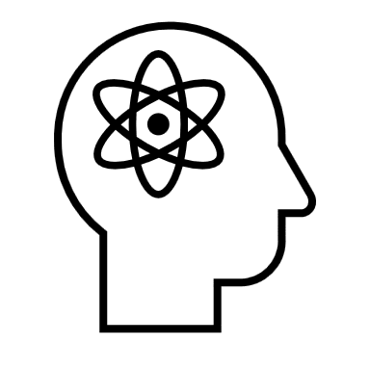
Welcome to Level 3 BTEC Applied Science! We are thrilled that you are thinking of taking on a dynamic option equivalent to one whole A Level that incorporates all three Sciences and is incredibly hands on. BTEC Courses are different to A Levels in that whilst you may have end of year exams, there is greater emphasis on developing a range of practical and investigative skills as part of the coursework element.
This summer bridging booklet is designed to help you ease the transition or bridge the gap from GCSE Science to BTEC Applied Science and give you a flavour of what studying Science at ICC might entail. All tasks have been chosen because they can directly be used in your coursework and because they will help structure your thoughts to become the best scientist you can be in September.

For all subjects, summer bridging work will reassure you that the subject you have selected is for you or allow you time to change your choice of subject at enrolment, as long as there is space, and you meet the entry criteria. The Applied Science team wants you to be happy and study a course that interests you and you are sufficiently qualified to study.

How to complete the summer bridging work

There are 5 tasks in total. Read through task each below and complete them either on lined paper or electronically as a Word or PowerPoint document. You are free to add pictures, photos, diagrams, colour to your work. You may wish to complete 1 task weekly during the summer holidays. Each task has a suggested word count in brackets e.g. (suggested word count 100 – 300 words). This is a guide for how long your response is expected to be.

You will be expected to bring your completed work with you and physically hand it in to your teacher. You may also email completed work to any of your Applied Science teachers. Deadline for submitting summer bridging work: Friday 15th September 2023.

Summer bridging work tasks

Task 1: All about me (Suggested word count: 100- 300 words)
- Why have you chosen to take Applied Science?
- What would you like to do in the future? (If unsure think about hobbies, interests, jobs, where you would like to be in 1 year, 3 years, 10 years’ time)
- What do you enjoy the most about Science?

Task 2: What is Science? (Suggested word count: 150- 300 words)
Science can be divided into 3 general branches: Biology, Chemistry and Physics. In the Applied Science course you will be studying all 3 branches. The following questions will help you consider what is Science?
- You learnt about 10 Big Ideas of Science between Year 7 to 11. List all 10 Big Ideas of Science.
- Give 5 examples of categories or branches that fall under Biology, Chemistry and Physics. For example, branches of Biology include Ecology, Microbiology and Cell Biology.
- What does ‘applied science’ mean?
- What is a scientist? (E.g., What do they do, what are some examples of careers in science, can anyone be a scientist?)

Task 3: Personal Development (Suggested word count: 200- 300 words)
- What are your personal strengths and weaknesses?
- What sort of scientist would you like to be by the end of the course? (Think about the skills you will have developed, what an average day in your life might look like, which areas of Science you would like to become more knowledgeable in)
- Check you have a library card or sign up to your local library. This will be essential for task 4. Most local libraries including Crawley library have signed up to Libby- a free digital library which can be accessed on phones, tablets, laptops etc- you will need a physical library card to sign up to Libby.

Task 4: Think like a Scientist
The best scientists stay curious about the world throughout their lives, not just for academic study. Over summer, during the course and post sixth form life you can develop your scientific knowledge and understanding by reading around the subject, watching videos and documentaries etc. Below is a list of different resources to look at to help you enjoy Science and learn more about it. The list is not exhaustive, only a starting point and you are not expected to use every single resource listed below.

You need to use two resources from the list below. For each resource, write a 200 - 300 word summary of what you enjoyed and learnt from it.

Suggested resources:

- Watch a Science documentary of your choice available on BBC IPlayer (www.bbc.co.uk/iplayer/categories/science-and-nature/featured)

- Read an article from a Science magazine or journal of your choice from your local library or using the Libby digital library app (https://arena.westsussex.gov.uk/eLibrary). Don’t be afraid to talk to librarians if you need help with getting a book out or using Libby- they are there to help you. Examples of magazines/journals- New Scientist, BBC Science Focus, How it works.
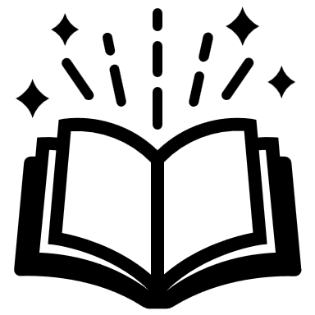
- Read a popular science book of your choice from your local library or using the Libby digital library app (https://arena.westsussex.gov.uk/eLibrary). Examples of popular science books you could read: Sapiens- A brief history of humankind (Yuval Noah Harari), Everything you know about science is wrong (Matt Brown), The immortal life of Henrietta Lacks (Rebecca Skloot), Bad Science (Ben Goldacre), A short history of nearly everything (Bill Bryson).

- Read a Science news article of your choice using one of the following websites:
- https://www.snexplores.org/
- https://www.theguardian.com/science
- https://www.bbc.co.uk/news/science_and_environment
- https://www.sciencenews.org/
- https://theconversation.com/uk/technology

Task 5: Subject Knowledge
Flipped learning is a brilliant way of preparing students for independent learning and managing their own time. This will be used in all sixth form subjects. Flipped learning is typically set and designed to be used within the next few lessons e.g., for answering multiple choice questions, exam questions etc. If flipped learning is not completed and brought in for the lesson it is required in, you may struggle to access the lesson.

To help you get used to flipped learning, below are some questions for you to complete that you will later rely on using in lessons:

Biology
- Label the diagram of the cell and describe the organelles functions that you have labelled.
- Explain 2 specialised cells and how they are adapted to their function.
- Describe the path blood takes around the body. You should include: heart, lungs, vein, artery, capillary
- How does the reflex arc work?

Chemistry
- Describe how chromatography works.
- Explain the reactivity of group 1 metals.
- Why is nitrogen a gas at room temperature?
- Draw the ions in sodium chloride.

Physics
- Describe the parts of the electromagnetic spectrum.
- Describe an experiment that could work out the density of an irregular object.
- Explain how refraction works.
- How can you calculate the velocity of an object?

End of booklet- Enjoy your summer!

