Preparation for Forensic Investigation Course
Welcome and congratulations on taking this interesting and diverse subject. We look forward to working with you.
To prepare you for the course, please complete the following tasks. This will also help our decision as to whether you are suitable for this course.

Deadline for hand in: Friday 16th September

Task 1 – what is forensics?
Task 2 – subject knowledge
Task 3 – applications of forensics
Task 4 – Research task
Task 5 – self assessment
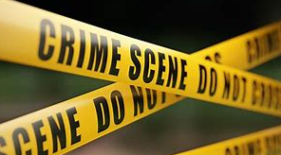
Task 1 – What is forensics
Answer the following questions
- What does forensic science mean?
- Give 4 careers related to forensics
- Why is it important that a forensics team are independent of the police?
- Suggest why forensics is so important in solving crimes
- Describe why you want to study forensics

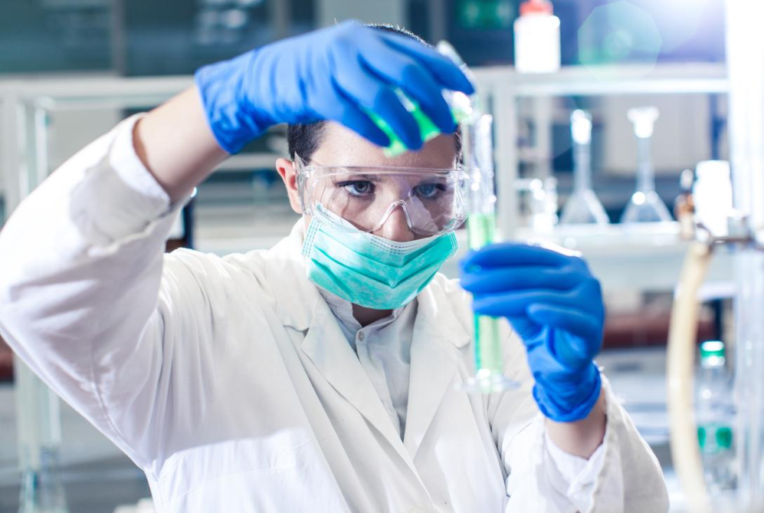

Task 2 – Subject knowledge
Answer the following questions

Biology
- Label the diagram of the cell and describe the organelles functions that you have labelled.
- Explain 2 specialised cells and how they are adapted to their function.
- Describe the path blood takes around the body. You should include: heart, lungs, vein, artery, capillary
- How does the reflex arc work?

Chemistry
- Describe how chromatography works.
- Explain the reactivity of group 1 metals.
- Why is nitrogen a gas at room temperature?
- Draw the ions in sodium chloride.

Physics
- Describe the parts of the electromagnetic spectrum.
- Describe an experiment that could work out the density of an irregular object.
- Explain how refraction works.
- How can you calculate the velocity of an object?
Task 3 – Applications of forensics
Research a branch of forensics (Choose one of the following) and make a short information pack about its key points. This should be no longer than 1 A4
You should include:
- What the branch is
- Brief explanation of the science
- Possible techniques and machines they use
- Why it is useful / what situations it might be utilised

Branches of forensics (this list is not exhaustive)
Anthropology  Ballistics  Chemical analysis  Collision analysis  Dental forensics | Digital forensics  DNA analysis  Fires and explosives  Forensic archaeology  Forensic photography  Medicinal chemistry

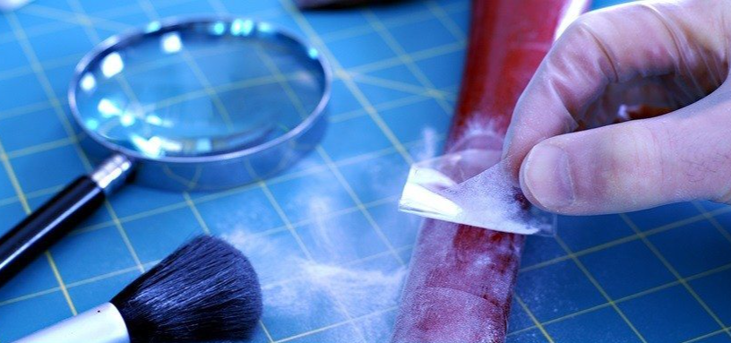

Task 4 – Research task
Research a crime that was committed that forensic science was instrumental in convicting the suspect. This should be no more than 1 A4. Remember, keep it sensible, short, factual and not too gory!
You should include:
- What the crime was (when it happened, who was involved)
- What the evidence was
- How forensics science helped solve the crime (what was the evidence and how was it processed, how did they catch the culprit)
- This case should be UK based.

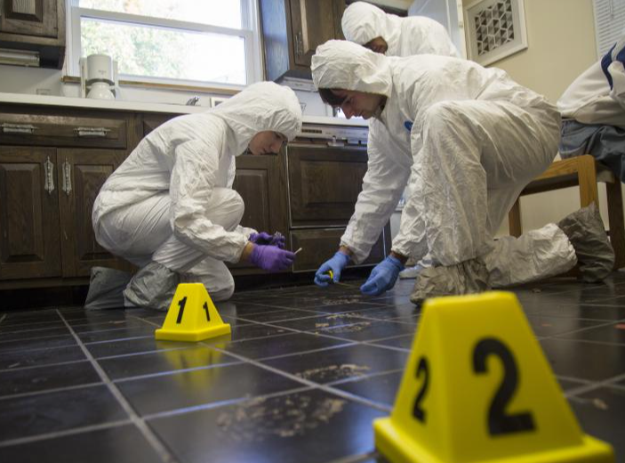
Task 5 – Self assessment
- In the table below, mark how you would assess your confidence in areas A–L using the rating scale of 1 = low and 10 = high.

Learning Factor
- Purpose
- Motivation
- Relationships
- Planning
- Practical skills
- Memory
- Resources
- Creativity
- Reading
- Listening
- Note-making
- Assessment

- Write down the areas where you both feel strongest and the areas where you consider yourself weakest. Think of one way to raise your competence on the weakest factor

